Read the Chapter 16 Case: "The Anatomy of a Spin-Off - Northrop Grumman Exits the Shipbuilding Business" and the Chapter 18 Case: "Ireland-Based Drug Maker Actavis Buys U.S. Pharmaceuticals Firm Forest Labs" in the textbook and respond to the questions related to each case using a minimum of 750 words.
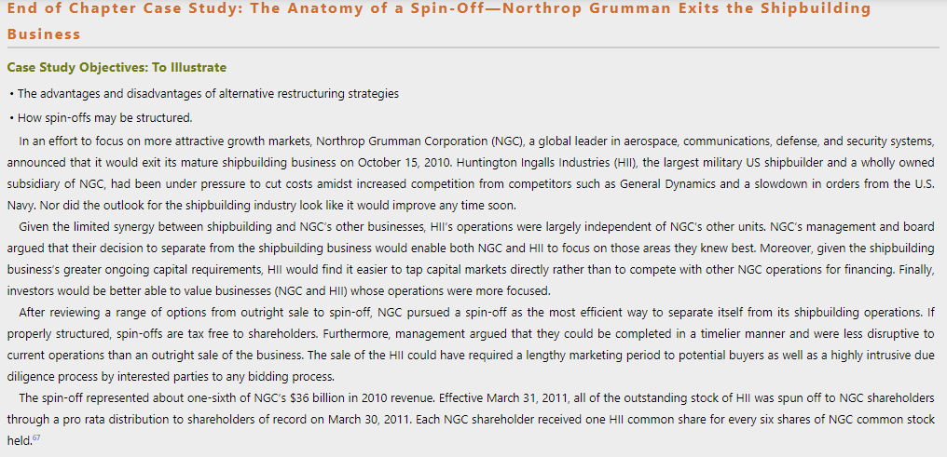
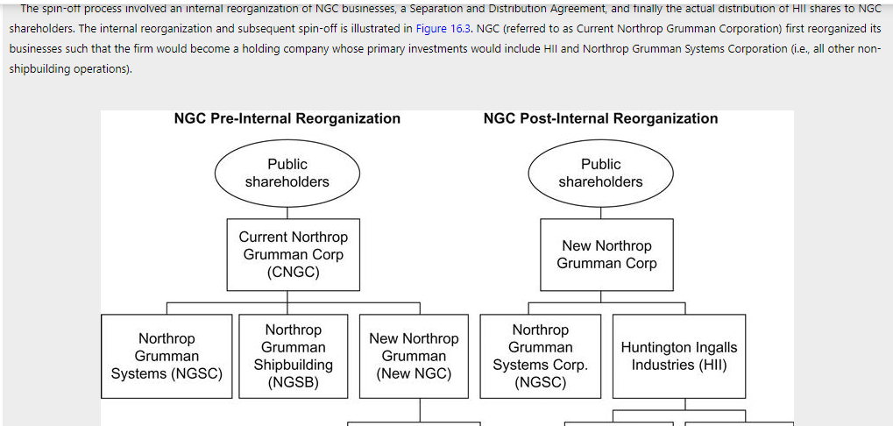
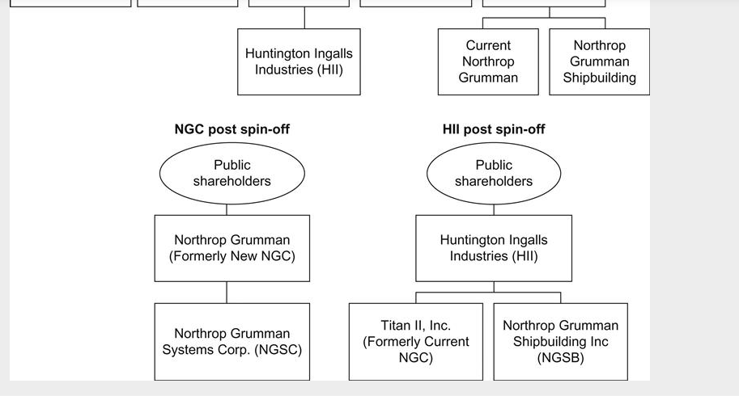
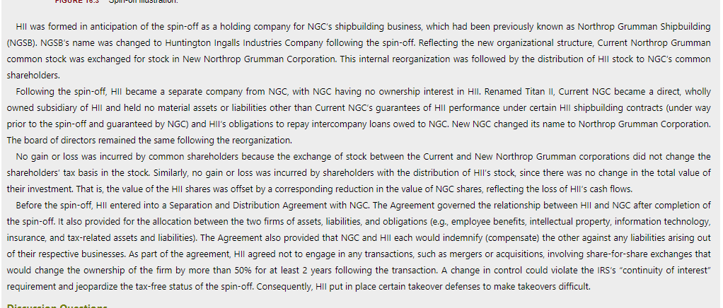
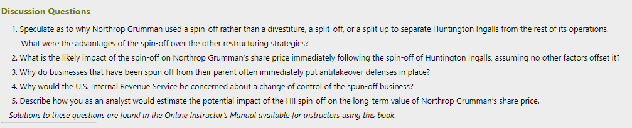
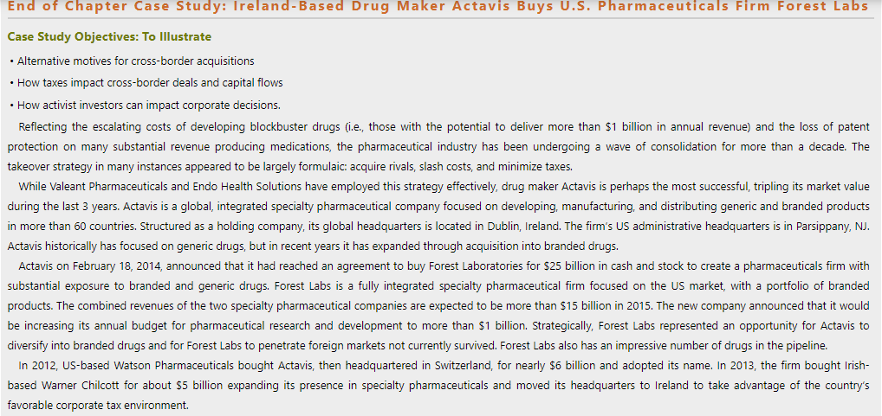
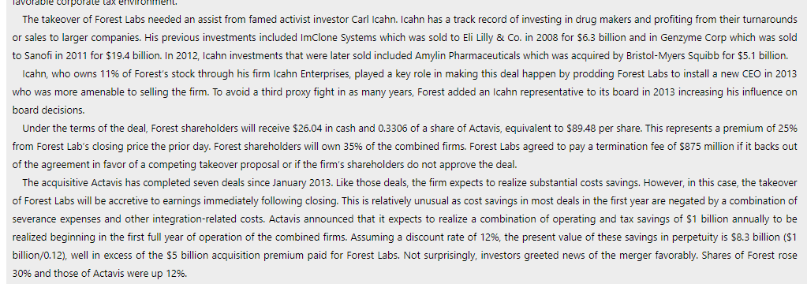
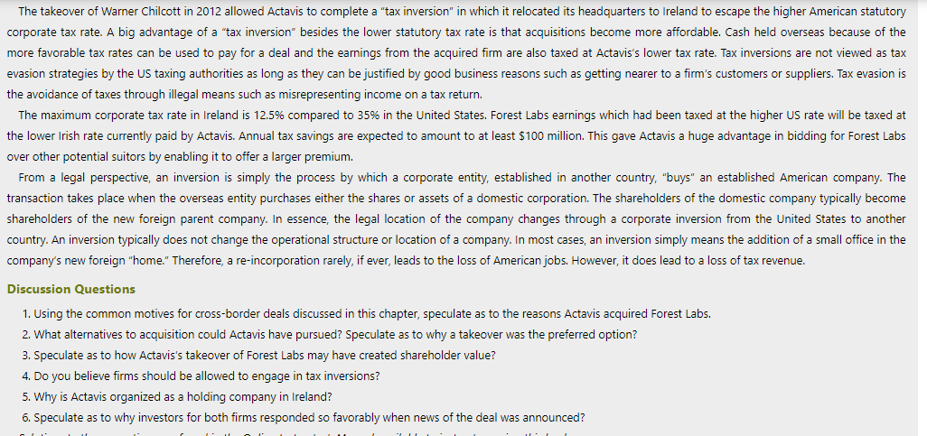

Baker, M., Coval, J., & Stein, J. C. (2007). Corporate financing decisions when investors take the path of least resistance. Journal of Financial Economics, 84(2), 266-298
DePamphilis, D. (2015). Mergers, acquisitions, and other restructuring activities (8th ed.). New York, NY: Elsevier Academic Press. ISBN-13: 9780128013908

